MILESTONE 1
1. Milestone Overview
Milestone 1 is titled “Creation Of Spreadsheet And Table”. The milestone contains two activities: (1) Creation of Spreadsheet and (2) Creation of Tables. The project uses spreadsheet data as the source for importing employee information into ServiceNow through Import Sets and Transform Maps.
Milestone Detail | Value
Milestone | Milestone 1: Creation Of Spreadsheet And Table
Project | Import Data using Transform Maps (Spreadsheet)
Complexity | Medium
Duration | 40 minutes
Stories | Creation Of Spreadsheet; Creation Of Tables

2. Objective
The objective of this milestone is to prepare the spreadsheet source data and create the ServiceNow tables required for the employee data import workflow. The spreadsheet contains employee information, while the tables provide the structure required for storing and staging the imported records.

3. Story 1 – Creation Of Spreadsheet
The spreadsheet is used as the source file for employee information. It contains employee details such as Employee ID, Employee Name, Email, Department, and Location. The prepared spreadsheet is downloaded in Excel format for use in the import process.

3.1 Procedure
Step 1: Open a new Google Spreadsheet.
Step 2: Create the sample employee data in the spreadsheet.
Step 3: Arrange the data in a structured tabular format.
Step 4: Check the entered data before downloading the spreadsheet.
Step 5: Download the spreadsheet in Excel format as “Sample Spreadsheet.xlsx”.

3.2 Spreadsheet Data Fields
Field | Description
Employee ID | Unique employee identifier used in the project data.
Employee Name | Name of the employee.
Email | Employee email information.
Department | Department associated with the employee.
Location | Location associated with the employee.

3.3 Output
The output of this activity is the Excel file “Sample Spreadsheet.xlsx”, which is prepared as the source data for the ServiceNow import workflow.

4. Story 2 – Creation Of Tables
The Import Set Table acts as a temporary staging table for data uploaded from the spreadsheet. The imported spreadsheet records are stored in the staging area before transformation. A custom Employee Test table is also created as the target table for the employee information.

4.1 Navigation
ServiceNow → Tables → Create New

4.2 Create the Employee Test Custom Table
Create a custom table named “Employee Test”. The table name specified in the project material is “u_employee_test”. The table is used as the target employee table for the later Transform Map process.
Table Property | Value
Table Label | Employee Test
Table Name | u_employee_test

4.3 Employee Test Fields
Field | Purpose
Employee ID | Stores the corresponding employee information from the spreadsheet.
Employee Name | Stores the corresponding employee information from the spreadsheet.
Email | Stores the corresponding employee information from the spreadsheet.
Department | Stores the corresponding employee information from the spreadsheet.
Location | Stores the corresponding employee information from the spreadsheet.

4.4 Create the Employee Import Table
Create the import/staging table named “Employee Import”. The project material specifies the table name as “u_employee_import”. This table is used to hold the uploaded spreadsheet records before they are transformed into the Employee Test table.
Table Property | Value
Table Label | Employee Import
Table Name | u_employee_import
Purpose | Temporary staging of uploaded spreadsheet data

5. Milestone 1 Workflow
Google Spreadsheet → Sample Employee Data → Sample Spreadsheet.xlsx → Employee Import (Staging Table) → Employee Test (Target Table)

6. Expected Result
At the end of Milestone 1, the project should have a prepared Excel source file and the required ServiceNow tables. The spreadsheet is ready to be uploaded, the Employee Import table is available for staging imported records, and the Employee Test table is available as the target table for the subsequent Transform Map activity.

7. Milestone 1 Completion Checklist
☐ Google Spreadsheet created.
☐ Sample employee data entered.
☐ Spreadsheet checked and downloaded as Sample Spreadsheet.xlsx.
☐ Employee Test custom table created.
☐ Employee Test table name set to u_employee_test.
☐ Employee ID, Employee Name, Email, Department, and Location fields prepared.
☐ Employee Import staging table created.
☐ Employee Import table name set to u_employee_import.

8. Conclusion
Milestone 1 establishes the spreadsheet and table structure required for the ServiceNow employee data import project. The spreadsheet provides the source employee data, while the staging and target tables provide the required structure for the later Import Set and Transform Map process.

9. Outputs
The sample spread sheet is created
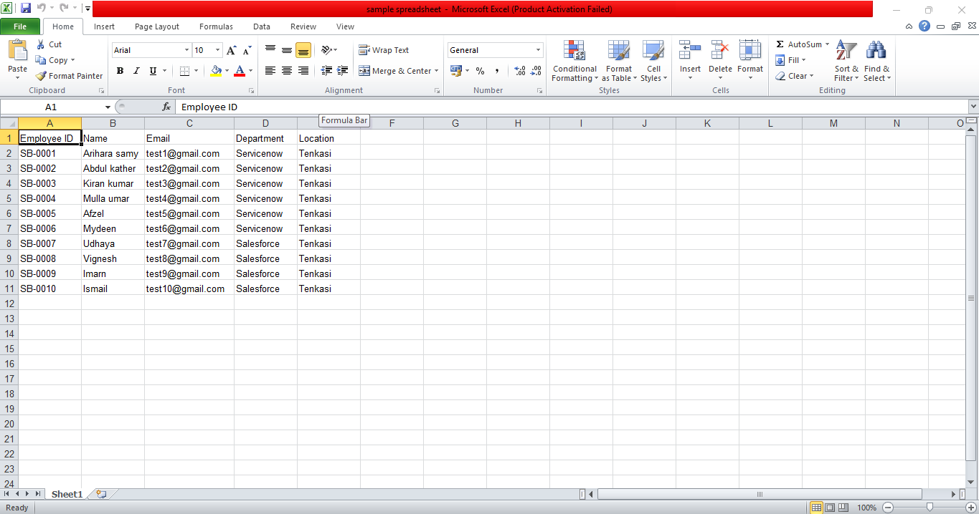
The creation of table is created
